
Faculty of Science

Course: CSCI 2020u – Software System Development & Integration
Component: Assignment
Weight: 10%
Deadline: March 6, 2019 (due by 11:59pm)

Collaboration Policy
You are permitted to work on this assignment in a team, and submit the results as a team. For this sort of assignment, with an open-ended component, the collaboration between multiple team members can be beneficial. Between groups, however, please limit the discussion to the level of general strategy (not code). Groups of size 2 are recommended. Larger groups will be considered with the proviso that the marker will mark your assignment with higher expectations. In any case, be sure that all members of the team fully understand all code, otherwise they will miss intended learning objectives, which may be a considerable disadvantage at exam time.

How to Submit
You will maintain a git repository for this assignment, which is a public repository. To submit the assignment, create a single file ‘README.txt’ that contains instructions on how to download, compile, and run your codes for each question. A .zip, .7z, or .rar file will not be acceptable. Also submit this word file (once you complete) into related drop box on Blackboard before deadline.

Note: Comments are mandatory. Failure to properly document your program will result in a deduction on the marks you receive for this (and any other) assignment.

Remember:
You need to complete this file and submit it in related drop box on Blackboard, in addition to uploading your codes in your git repository, before deadline.

Question 1: Displaying Three Cards

Problem Description:
Display a frame that contains three labels. Each label displays a card, as shown in the figure below. The card image files are named 1.png, 2.png, ..., 54.png and stored in the image/card directory. All three cards are distinct and selected randomly.

The image icons can be found in the attached card folder.

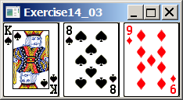

Your Task:
- Create three ImageView and set their icons using the images.
- Display three images from 54 image cards randomly.

Your Code:
Copy-paste your code here:
package displaycards;

import java.util.ArrayList;
import javafx.scene.image.ImageView;
import javafx.scene.image.Image;
import javafx.scene.layout.HBox;
import javafx.application.Application;
import javafx.scene.Scene;
import javafx.stage.Stage;

/**
* @author Cynthia Chang
*/
public class DisplayCards extends Application {

@Override
public void start(Stage primaryStage) {
ArrayList<String> cardsList = new ArrayList<>();

for (int i = 0; i < 54; i++) {
cardsList.add(String.valueOf(i + 1)); // adds a number into the list from 1 to 54
}

java.util.Collections.shuffle(cardsList); // method that randomly permutes the list

ImageView card1 = new ImageView(new Image("Cards/" + cardsList.get(0) + ".png")); //gets image of card1 from Cards folder
ImageView card2 = new ImageView(new Image("Cards/" + cardsList.get(1) + ".png")); //gets image of card2 from Cards folder
ImageView card3 = new ImageView(new Image("Cards/" + cardsList.get(2) + ".png")); //gets image of card3 from Cards folder

HBox root = new HBox(); //creates a horizontal box

// all images are placed horizontally
root.getChildren().add(card1);
root.getChildren().add(card2);
root.getChildren().add(card3);

Scene scene = new Scene(root);

primaryStage.setTitle("Display Three Cards");
primaryStage.setScene(scene);
primaryStage.show();
}

public static void main(String[] args) {
launch(args);
}
}

Screen shots:
Include two screen shots here:
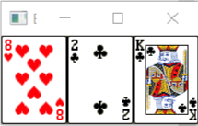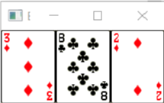

Question 2: Investment-Value calculator

Problem Description:
Write a program that calculates the future value of an investment at a given interest rate for a specified number of years. The formula for the calculation is as follows:

futureValue = investmentAmount * (1 + monthlyInterestRate)years*12

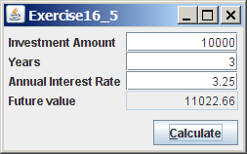

Your Task:
Use text fields for interest rate, investment amount, and years. Display the future amount in a text field when the user clicks the Calculate button, as shown in the figure.

Your Code:
Copy-paste your code here.
package investmentcalculator;

import javafx.application.Application;
import javafx.event.ActionEvent;
import javafx.scene.Scene;
import javafx.scene.control.TextField;
import javafx.scene.control.Button;
import javafx.scene.control.Label;
import javafx.scene.layout.GridPane;
import javafx.geometry.Pos;
import javafx.geometry.HPos;
import javafx.geometry.Insets;
import javafx.stage.Stage;

/**
* @author Cynthia Chang
*/
public class InvestmentCalculator extends Application {
private TextField investAmount = new TextField();
private TextField numOfYears = new TextField();
private TextField interestRate = new TextField();
private TextField futureValue = new TextField();
private Button calculate = new Button("Calculate");

@Override
public void start(Stage primaryStage) {
// creates template of interface
GridPane pane = new GridPane();
pane.setVgap(2); // sets vertical spacing
pane.setHgap(5); // sets horizontal spacing
pane.add(new Label("Investment Amount"), 0, 0);
pane.add(investAmount, 1, 0);
pane.add(new Label("Years"), 0, 1);
pane.add(numOfYears, 1, 1);
pane.add(new Label("Annual Interest Rate"), 0, 2);
pane.add(interestRate, 1, 2);
pane.add(new Label("Future Value"), 0, 3);
pane.add(futureValue, 1, 3);
pane.add(calculate, 1, 4);

// sets the interface properties
pane.setAlignment(Pos.CENTER);
investAmount.setAlignment(Pos.BOTTOM_RIGHT);
numOfYears.setAlignment(Pos.BOTTOM_RIGHT);
interestRate.setAlignment(Pos.BOTTOM_RIGHT);
futureValue.setAlignment(Pos.BOTTOM_RIGHT);
futureValue.setEditable(false); // makes the textBox of futureValue uneditable
GridPane.setHalignment(calculate, HPos.RIGHT);
pane.setPadding(new Insets(10, 10, 10, 10));

// sets the calculated value onto the textfield of futureValue
calculate.setOnAction((ActionEvent e) -> {
calcFutureValue();
});

Scene scene = new Scene(pane);
primaryStage.setTitle("Investment-Value Calculator");
primaryStage.setScene(scene);
primaryStage.show();
}

private void calcFutureValue() {
double investmentAmount = Double.parseDouble(investAmount.getText());
int years = Integer.parseInt(numOfYears.getText());
double monthlyInterestRate = Double.parseDouble(interestRate.getText()) / 1200;
futureValue.setText(String.format("$%.2f", (investmentAmount * Math.pow(1 + monthlyInterestRate, years * 12))));
}
}

Screen shots:
Include two screen shots here:
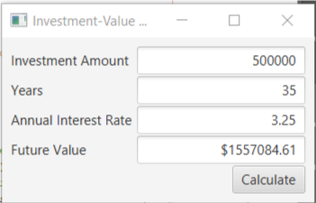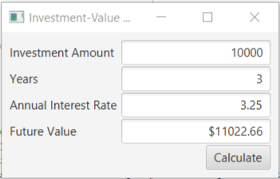

Question 3: Dragging Points on a Circle

Problem Description:
Draw a circle with three random points on the circle. Connect the points to form a triangle. Display the angles in the triangle. Use the mouse to drag a point along the perimeter of the circle. As you drag it, the triangle and angles are redisplayed dynamically.

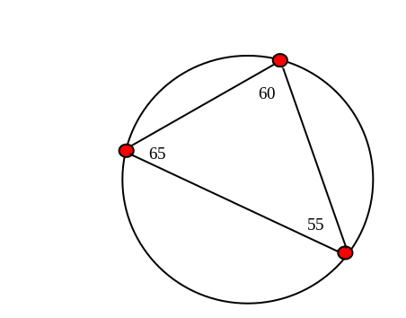

Here is the formula to compute angles:

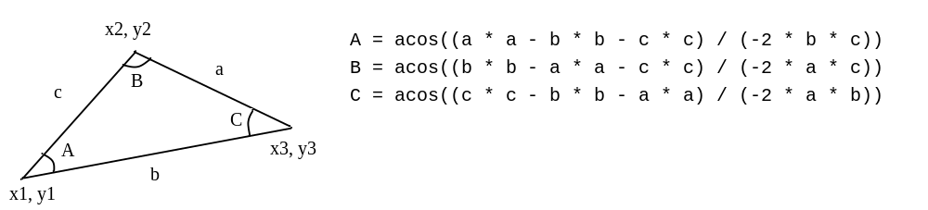

Your Code:
Copy-paste your code here:
package draggingpoints;

import javafx.application.Application;
import javafx.scene.Scene;
import javafx.scene.layout.Pane;
import javafx.scene.shape.Circle;
import javafx.scene.shape.Line;
import javafx.scene.text.Text;
import javafx.stage.Stage;
import javafx.event.EventHandler;
import javafx.beans.property.DoubleProperty;
import javafx.scene.input.MouseEvent;
import javafx.scene.layout.BorderPane;
import javafx.scene.text.Font;
import javafx.scene.text.TextAlignment;
import javafx.beans.value.ChangeListener;
import javafx.beans.value.ObservableValue;
import javafx.scene.paint.Color;

/**
* @author Cynthia Chang
*/
public class DraggingPoints extends Application {
@Override
public void start(Stage primaryStage) {
//sets properties of window pane
PointPane pane = new PointPane(300, 300);
BorderPane borderPane = new BorderPane(pane);

Scene scene = new Scene(borderPane);
primaryStage.setTitle("Dragging Points on a Circle");
primaryStage.setScene(scene);
primaryStage.show();
}

private class PointPane extends Pane {
Circle circle = new Circle();
Vertex[] vertex = new Vertex[3];
int strokeWidth = 1; // sets the width of the lines
Color circleStroke = Color.BLACK, legStroke = Color.BLACK;

PointPane(double w, double h) {
setPrefSize(w, h);
setWidth(w);
setHeight(h);

// set properties for the large circle
circle.setStroke(circleStroke);
circle.setFill(Color.TRANSPARENT);
circle.setStrokeWidth(strokeWidth);
circle.radiusProperty().bind(heightProperty().multiply(0.3));
circle.centerXProperty().bind(widthProperty().divide(2));
circle.centerYProperty().bind(heightProperty().divide(2));
this.getChildren().add(circle);

// set properties for each vertex
for (int i = 0; i < vertex.length; i++) {
vertex[i] = new Vertex(circle, 2 * Math.PI / vertex.length * (i + Math.random()));
vertex[i].radiusProperty().bind(circle.radiusProperty().divide(15));
vertex[i].setPosition();
vertex[i].setStroke(circleStroke);
vertex[i].setFill(Color.RED);
vertex[i].setStrokeWidth(strokeWidth);
this.getChildren().add(vertex[i]);

// handles mouse events when dragging the vertices
vertex[i].setOnMouseDragged(new EventHandler<MouseEvent>() {
@Override
public void handle(MouseEvent event) {
int i;
for (i = 0; i < vertex.length; i++)
if (vertex[i] == event.getSource())
break;
vertex[i].setAngle(event.getX(), event.getY());
moveUpdate((Vertex)event.getSource());
}
});
}

for (int i = 0; i < vertex.length; i++) {
int j = i + 1 < vertex.length ? i + 1 : 0;
int k = j + 1 < vertex.length ? j + 1 : 0;
vertex[i].bindLeg(vertex[j], vertex[k]);
vertex[i].line.setStroke(legStroke);
vertex[i].line.setStrokeWidth(strokeWidth);
this.getChildren().add(vertex[i].line);
this.getChildren().add(vertex[i].text);
}

for (DoubleProperty p: new DoubleProperty[] {
circle.radiusProperty(), circle.centerXProperty(), circle.centerYProperty()
})
p.addListener(new ResizeListener()); // adds a tracker to the angle of vertex
moveUpdate(vertex[0]);
}

// tracks the angle of the vertex
void moveUpdate(Vertex point) {
point.setPosition();
double[] lineLength = new double[3];
for (int i = 0; i < vertex.length; i++)
lineLength[i] = vertex[i].getLineLength();

for (int i = 0; i < vertex.length; i++) {
int j = i + 1 < vertex.length ? i + 1 : 0;
int k = j + 1 < vertex.length ? j + 1 : 0;
double a = lineLength[i], b = lineLength[j], c = lineLength[k];
double d = Math.toDegrees(Math.acos((a * a - b * b - c * c) / (-2 * b * c)));
vertex[i].setText(d);
}
}

private class ResizeListener implements ChangeListener<Number> {
@Override
public void changed(ObservableValue<? extends Number> observableValue, Number oldWidth, Number newWidth) {
for (Vertex vertex2 : vertex) {
vertex2.setPosition();
}
}
}
}

private class Vertex extends Circle {
Circle circle;
Line line;
Text text;
double centerAngle;

// set properties of the angle text
Vertex(Circle circle, double centerAngle) {
this.circle = circle;
this.setAngle(centerAngle);
line = new Line();
text = new Text();
text.setFont(Font.font(18));
text.setStroke(Color.BLACK);
text.setTextAlignment(TextAlignment.CENTER);
text.xProperty().bind(this.centerXProperty().add(25));
text.yProperty().bind(this.centerYProperty().subtract(10));
}

double getCenterAngle() {
return this.centerAngle;
}

void setPosition() {
this.setCenterX(circle.getCenterX() + circle.getRadius() * Math.cos(this.getCenterAngle()));
this.setCenterY(circle.getCenterY() + circle.getRadius() * Math.sin(this.getCenterAngle()));
}

void setAngle(double centerAngle) {
this.centerAngle = centerAngle;
}

void setAngle(double x, double y) {
this.setAngle(Math.atan2(y - circle.getCenterY(), x - circle.getCenterX()));
}

void bindLeg(Vertex v1, Vertex v2) {
line.startXProperty().bind(v1.centerXProperty());
line.startYProperty().bind(v1.centerYProperty());
line.endXProperty().bind(v2.centerXProperty());
line.endYProperty().bind(v2.centerYProperty());
}

double getLineLength() {
return Math.sqrt(Math.pow(line.getStartX() - line.getEndX(),2) + Math.pow(line.getStartY() - line.getEndY(),2));
}

void setText(double angle) {
this.text.setText(String.format("%.0f", angle));
}
}
}

Screen shots:
Include two screen shots here:
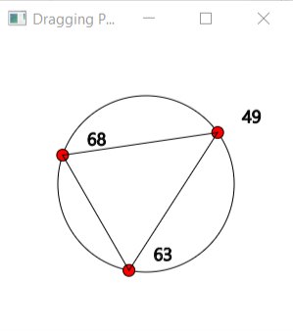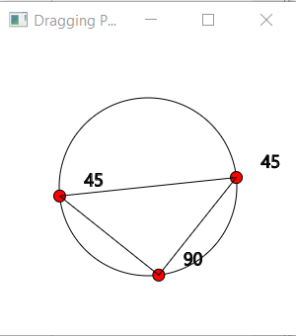
Question 4: Histogram

Problem Description:
Develop a program that displays a histogram to show the occurrences of each letter in a text area. The histogram should show the occurrences of each letter in a text file, as shown in the following figure. Assume that the letters are not case sensitive.

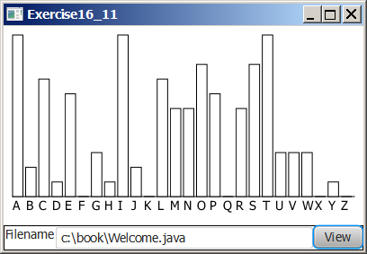

Your Task:
- Place a pane that will display the histogram in the center of the frame.
- Place a label and a text field in a panel, and put the panel in the south side of the frame. The text file will be entered from this text field.
- Pressing the Enter key on the text field causes the program to count the occurrences of each letter and display the count in a histogram.

Your Code:
Copy-paste your code here:
package histogram;

import javafx.application.Application;
import javafx.scene.Scene;
import javafx.scene.control.Button;
import javafx.scene.control.TextField;
import javafx.scene.layout.HBox;
import javafx.scene.layout.VBox;
import javafx.stage.Stage;
import javafx.geometry.VPos;
import javafx.scene.control.ContentDisplay;
import javafx.scene.control.Label;
import javafx.scene.layout.GridPane;
import javafx.scene.layout.Pane;
import javafx.scene.shape.Rectangle;
import java.io.File;
import java.io.IOException;
import java.util.Scanner;

/**
* @author Cynthia Chang
*/
public class Histogram extends Application {
Pane pane = new Pane();
TextField namefield = new TextField();
VBox vbox = new VBox();

@Override
public void start(Stage primaryStage) {
Label fileName = new Label("Filename", namefield);
fileName.setContentDisplay(ContentDisplay.RIGHT); //sets fileName label to the right
namefield.setPrefColumnCount(20); // shows 20 cols in the textfield
Button viewButton = new Button("View");
HBox hbox = new HBox(fileName, viewButton);
vbox.getChildren().addAll(pane, hbox);
Scene scene = new Scene(vbox);
primaryStage.setScene(scene);
primaryStage.setTitle("Histogram");
primaryStage.sizeToScene();
viewButton.setOnAction(e -> {
updateHistogram();
vbox.setTranslateY(10);
primaryStage.sizeToScene();
primaryStage.setTitle("Histogram");
});
primaryStage.show();
}
private void updateHistogram() {
makeHistogram graph = new makeHistogram(namefield.getText());
pane.getChildren().add(graph);
}

// creates Histogram that counts the letters in a file
private static class makeHistogram extends Pane {
private char[] chars = new char[26];
private int counter[] = new int[26];
private Rectangle[] bars = new Rectangle[26];
private File file;
GridPane gridPane;
double width = 350;
double height = 350;
public makeHistogram(String filename) {
this.file = new File(filename.trim());
setWidth(width);
setHeight(height);
readFile();
drawHistogram();
}
// reads filename that is entered by user
private void readFile() {
Scanner scanner;
String s = "";
try {
scanner = new Scanner(file);
while (scanner.hasNextLine()) {
s += scanner.nextLine();
}
} catch (IOException e) {}
s = s.toUpperCase();
// counts the number of occurances of a letter
for (int i = 0; i < s.length(); i++) {
char character = s.charAt(i);
if (Character.isLetter(character)) {
counter[character - 'A']++;
}
}
}
private double getTotalCount() {
double total = 0; for (int count : counter) {
total += count;
}
return total;
}
// draws the histogram bars
private void drawHistogram() {
gridPane = new GridPane();
double barW = width / chars.length;
double total = getTotalCount();
for (int i = 0; i < counter.length; i++) {
chars[i] = (char)('A' + i);
double percentage = counter[i] / total;
double barH = height * percentage;
bars[i] = new Rectangle(barW, barH);
Label label = new Label(chars[i] + "", bars[i]);
label.setContentDisplay(ContentDisplay.TOP);
gridPane.add(label, i, 0);
GridPane.setValignment(label, VPos.BASELINE);
}
getChildren().addAll(gridPane);
}
public int[] getCounter() {
return counter;
}
public void setCounter(int[] counts) {
this.counter = counts;
drawHistogram();
}
}
}

Screen shots:
Include two screen shots here:
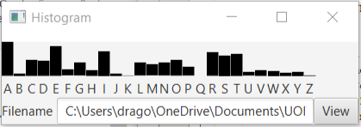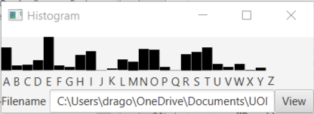
Remember:

You need to complete this file and submit it in related drop box on Blackboard, in addition to uploading your codes in your git repository, before deadline.

